Backstage Report-Sam Turner - Sam Turner

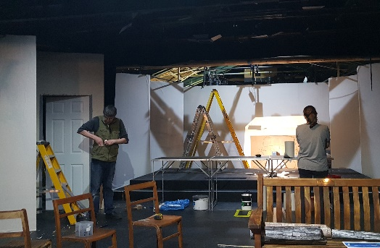
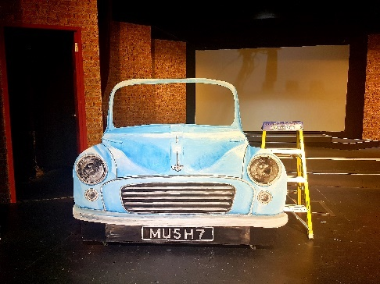
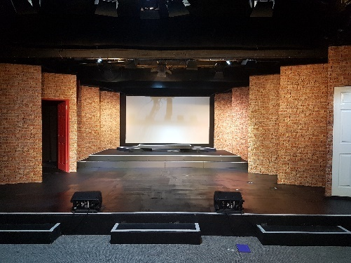
We began this season with Our House. After multiple delays for this show it was great to bring the set to life. Most challenging aspects included pattern matching brick wallpaper and working out how to create the iconic rotating doors. Lighting and sound had huge challenges for Our House, not only with sound effects, microphones, live band and projection system, but also in aligning cues to costume changes occurring off stage throughout the show. We had a big group of people volunteers to help crew this show so thank you to all.

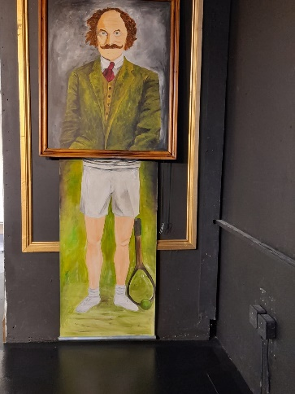
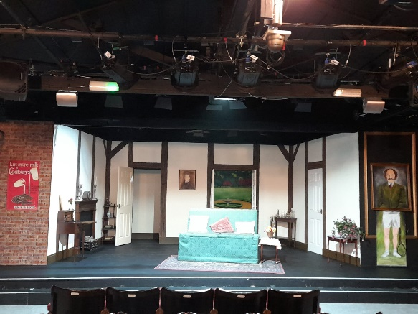
Our second show was Inspector Drake. This box set revolved around a bespoke sofa which the production team were able to source from another society up in Newcastle! Thanks goes out to Millie and Lara for helping to keep track of the hundreds of props required, we got most of them on stage at the correct times. Special thanks go to Pete who stepped in last minute to stage manage on the final night when I was unable to.

We then moved on to the biggest set challenge of the year, our panto Aladdin. This included the usual range of drops, curtains, trucks and wing flats, all requiring construction and painting. Special thanks to Nat and Di for creating the wide range of scenery, as well as the wider team who worked in relay across Christmas period to wallpaper and paint. The show itself had the usual challenges of a panto with lots of cast and scene changes. Thanks to all who helped crew the shows, especially Kris for his excellent dragon puppetry.
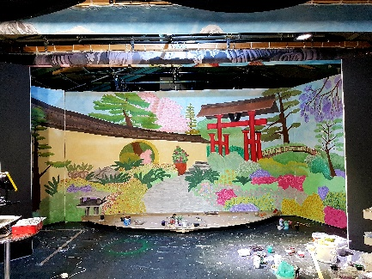
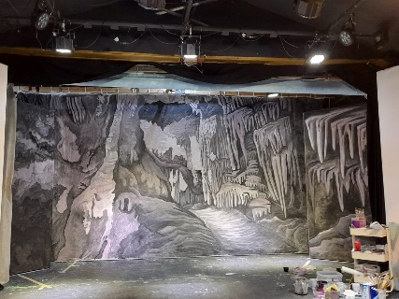
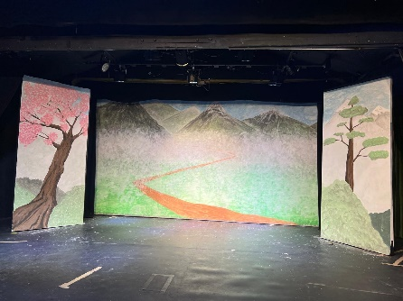
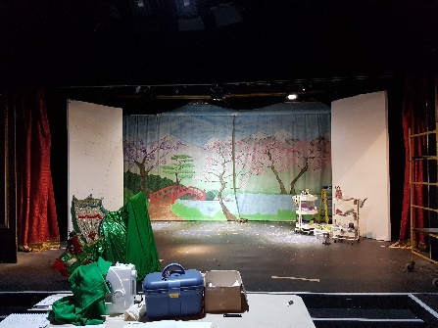
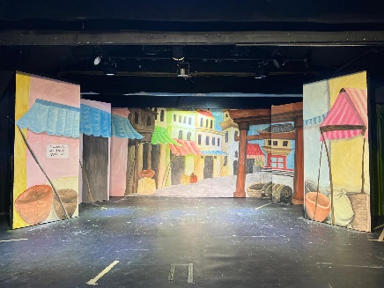
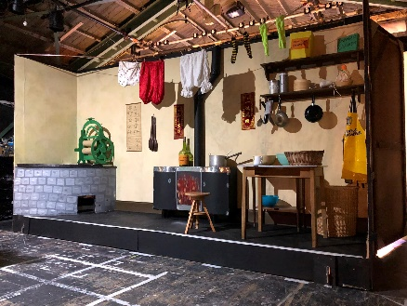

Our fourth show was Last Tango in Whitby which had a minimalist set with chairs used for the bus; most of the set had been built prior to storm Eunice, which delayed the show by eight months, so it was a quick re assembly of the set. The trial of a high-powered back projector was disappointing in that hired machine barely produced anything better than our own, at least we can eliminate that model from our wish list.

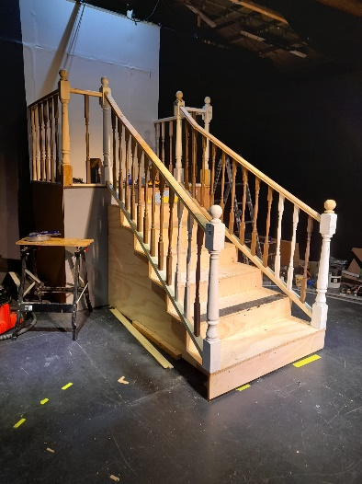
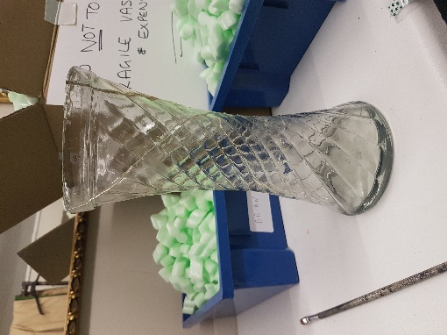
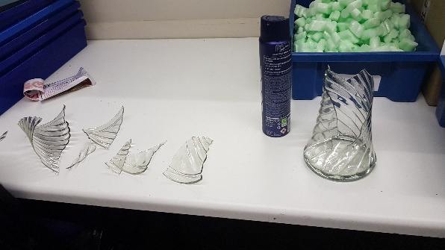
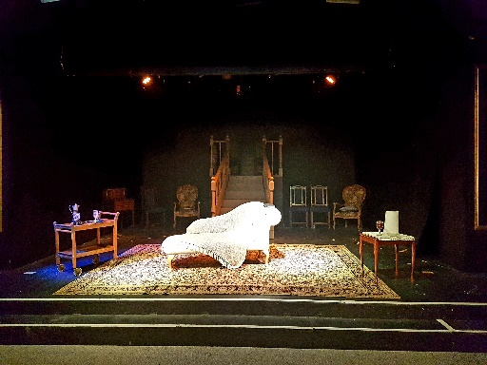
Our fifth show of the season was Ravenscroft in which the production team developed a very unique set design focused around a central staircase and chaise. Multiple carpentry lessons were run to get the staircase created and dressed appropriately, thanks go to Nat, Di, Yvonne and Dave. The show itself ran very smoothly up until the final night when half an hour before curtains up, it was discovered that our last breakable resin vase was broken in its box! Thanks to all who helped to problem solve the issue, both in finding glass replica in the prop store and advising on the best glues to use. The resin vase made it to the stage for second half and mostly broke to the scripted plan.

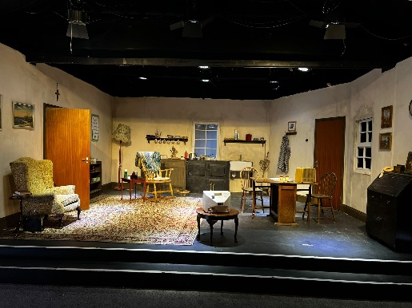
The final adult show of the year was Beauty Queen of Leenane. Another box set was created and the build crew took special delight in create damp and mould patterns on the walls. Extensive set dressing and specific props were required for this show, thanks to all who helped to buy and source the various items that were required.

Both YG shows this year were set on Black’s. Fabric Legs were made as an alternative to installing flats to mask the wings and allow easy access with props and furniture. The ‘snoopy’ blocks were dug out once again and used in various ways for both shows. The 2-week window for set construction was used to build all the required items specific for Grease.
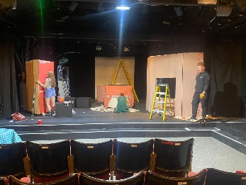
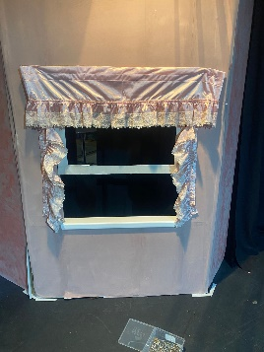
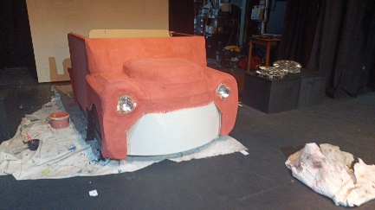

We are starting now to prepare for the start of the next season, and I would like to share a huge thank you to all of those who have helped at the theatre over the last 12 months. It has been a hugely challenging time for everyone getting back up to speed with a full season of shows after the last few years. The next season will be a big challenge, we have some fantastic shows lined up that we can’t wait to begin. If anyone can spare a few hours here and there to help out, the effort would be greatly appreciated. No skills or prior knowledge is needed, and there are always a wide range of tasks to be done both for shows and between shows.

Box Office Report – Derek Lockwood

Finally, we have a full season after Covid and storm Eunice.
The 2022-23 season saw a full programme delivering some postponed shows. The season kicked off with the rescheduled musical Our House which pre-sold 619 tickets for its 5 nights and was well received by the audience, with many of our regular audience commenting on how wonderful it was for us to be able to re-open.
The return season gave a higher average audience than the previous 7 seasons which reflects the successful season it has been.

Season | No. of Shows | Tickets pre-Sold (Ticketsource) | Avg Tickets sold per show
2014-15 | 10 | 2961 | 296.10
2015-16 | 11 | 2816 | 256.00
2016-17 | 11 | 2713 | 246.64
2017-18 | 11 | 2763 | 251.18
2018-19 | 10 | 2122 | 212.20
2019-20 | 10 | 2007 | 200.70
2020-21 | 6 | 307 | 51.17
2021-22 | 4 | 1174 | 293.5
2022-23 | 9 | 2897 | 321.89

I would like to thank Jan and Neil Fillingham, Sue Gowen and Graham Vockins for their assistance this season and wish Jan and Neil all the best in their move to Devon.
I would like to welcome Lara Savory to the Box Office ‘team’ and hope to arrange a refresher/learning session in September for anyone wishing to learn what is involved in running box office on show nights.
If anyone would like to learn how to run box office on show night please contact me by email at lockwoodderek@hotmail.com

Membership Report – Jane Minchin

It has been a welcome relief this past year to have a normal membership year where the drama has stayed mainly on the stage. With our theatre going from strength to strength following the storm damage in February 2022 (previous membership year) our membership numbers have stayed healthy recording 74 adult and 47 youth group members. It is particularly satisfying for me as membership secretary to have been able to make a huge positive impact with creating this role back in 2020 & executing on an on going regular basis financial and member information reconciliations to ensure treasury, youth group & membership records are correct. Carrying out this role in addition to all the other tasks around membership has indeed been both a mammoth and rewarding task, however not without its frustrations along the way. I have decided to pass on the batton as it were to others who I sincerely hope will continue to carry out all the regular necessary checks to ensure the continuation of the accurate records I have worked so very hard to create & maintain for the last 3 years.

Building Report - Graham Vockins
Following Storm Eunice in February 2022 the last items of tidying up ready for the new season starting with Our House were completed. This misfortune has had the effect of presenting us with new carpet, walls and ceiling in the Auditorium and new roof over the Stage which will reduce the maintenance load for a few years.
Work has continued completing the new Toilets in the Foyer with additional props storage space in the loft which now has lighting and toilet ventilation installed. We still have to complete fit out and decoration before it can be used for Props we only use every couple of years or so, thus freeing up space in the existing store for day to day items.
Emergency Lighting has been installed in the Wardrobe and will provide a three hour source of light if power fails, making it easier to exit the building.
We recently had a visit from the Fire Brigade and following this we commissioned a Fire Risk Assessment. Items identified by the report are being undertaken both in house and by contractors (New Fire Alarm panel and Smoke Detectors)
Our annual 3Hr Emergency lighting test has been done and I am delighted that for the first time in my thirty years of undertaking this check all 26 units passed. I believe that this is due to two reasons 1) we had seven units replaced following storm Eunice damage and 2) we have a majority of L.E.D. units which produce reduced battery drain.
Elsewhere in the building Gary continues working on Wi Fi and internet upgrades for which we thank him
We are currently upgrading and replacing defective car park lighting and have plans for a “porch” to the lawn side escape doors and drainage channel to the furniture store.
Steve Toon continues to support me during the day at SPT and I am grateful for his commitment and time spent.
It has not been possible to upgrade the Foyer this season as we have costs involved with the Fire Risk Assessment but hope we can do something next year

Production Liaison Report - Matt Chishick

After the disruption to our last season caused by storm Eunice, the 22/23 season allowed us to finally bring to the stage some productions that had been in the works since before the pandemic. This was my first year as Production Liaison and what a year it was! 4 plays, 1 musical, 1 pantomime and 2 youth group shows, all of which have had fantastic reviews and brought some of the best performances and largest audiences we have seen a long while.
The season opened with the long awaited and spectacular Our House - the musical inspired by the music of Madness. This show was originally planned for April 2020, was moved to April 2022 post-pandemic and then moved once again to October 2022 after the storm damage in February. Thanks to the hard work and determination of Lara Savory (Musical Director) and Heidi Ashton (Director), this was the perfect show to let everyone know that SPT was back in business with several of the performances playing to a full house. There are too many people to call out here that gave so much to make this show such a success, from Lindsay Belt’s amazing choreography to Pete Ashton putting the new lighting and sound setup through its paces. We also had our first NODA London District award winner of the season, with Matt Oxley receiving the Ken Wirdnam Award for Best Make Character in a Musical for his portrayal of Joe Casey.
In November 2022, Cate Naylor and Karen Bird brought Inspector Drake back to the Shinfield stage with David Tristram’s hilarious play, Inspector Drake and the Black Widow. Asheigh Wells and Keith Sullivan returned as Inspector Drake and Sergeant Plod ten years after performing these roles in Inspector Drake and the Perfekt Crime. They were joined by Alana Wells expertly supplying the remaining characters ranging from the mysterious Lady Devonshire to the hilarious Doctor Foster.
In December we celebrated the achievements of our Youth Groups with the Junior and Middle Youth Group review and the Senior Youth Group show Time After Time, closely followed by the annual Christmas Charity Show led by Cara Broadhurst.
In January it was panto season, and we were transported to Old Peking with Aladdin and the Valley of the Dragons, written and directed by Carol Vockins. Featuring everything you would expect from a panto - plus dragons! A large cast and crew helped bring this show to life, again with too many people to call out here, but there two more NODA awards for this show. Firstly for our amazing and hardworking set builders picking up the Shinfield Players Scenic Award for the set which included Old Peking, a palace garden and a laundrette on a full stage-width rotating truck, a cave with a smoke spewing dragon and a stunning UV flying sequence. The fabulous George Apap also stole both the lamp and the Nigel Gravette Award for Best Performance in a Pantomime for his performance as the wicked Abanazar.
Carol and Graham Vockins had no time to rest following the panto as they were quickly packing for a trip to Yorkshire with Last Tango in Whitby, another show that was postponed due to Storm Eunice. Unfortunately, at this time the gremlins struck the lighting rig and we started to experience flickering lights as well as some challenges with the projector needed for this production. Undeterred, the cast and crew went on to deliver a fantastic show which also earned Clare Kendall the Eric Watsham Award for Best Cameo Performance for her performance as Debbie.
In April, Maggie Smith and Cate Naylor brought Don Nigro’s Ravenscroft to the stage making effective use for a simple stage with a beautifully constructed staircase. Again, this show was plagued with issues with the lighting rig with flickering lights impacting some of the rehearsals and sadly even some of the performances but the cast showed their professionalism and talent by still delivering stunning performances. Special thanks to Ashleigh Wells for stepping into play Inspector Ruffing at very short notice.
Next up was The Beauty Queen of Leenane by Martin McDonagh’s, directed by Adam Wells. Again, this show had originally been cast with the intention of performing in 2022 and was postponed due to storm Eunice. Luckily the original 4 cast members were able to remain part of this production and finally had the chance to bring this play to the stage in June. The stage crew produced an authentic, rundown cottage kitchen set that perfectly set the scene for the play. Unfortunately, COVID decided to remind us that it was not fully gone and resulted in 2 of the 4 performances being cancelled. Nevertheless the 2 performances we managed were very well received and well worth the wait.
At the end of June, the Junior and Middle youth Group showcased their talents with modern adaptation of A Midsummer Night’s Dream - Dream On. Jo Oldach, Jamie Milburn and Joe Richardson did an outstanding job of guiding these young actors into putting in a wonderful performance.
This was quickly followed by the Senior Youth Groups production of Grease which ended the season with a bang. Two different casts allowed more of these talented young performers to take on principal characters. Performing to sell out audiences this was a huge hit and something for which all involved should be tremendously proud.
Special thanks to Pete Ashton for not only taking on the technical role for the youth group shows but also correcting the lighting challenges that had impacted some of the shows earlier in the season.
So that brings us to the end of a truly spectacular season, and while it may seem like we could never top it – we are already working on doing exactly that with both Betty Blue Eyes and The Tempest rehearsals well underway. There will be plenty of opportunities to get involved both on and off stage this coming season so please reach out to me if you want to find out more.

Publicity Officer Report – Graeme Rhodes
As a newbie to the role of Publicity Officer I am very grateful to the committee members for their patience, guidance and help in understanding and addressing the needs of the theatre.
We now have a coherent communications plan for shows which includes Jess Wilkins’ excellent, now full colour, posters and flyers, a standard programme format for directors to use, teaser social coverage on Facebook from Jess and promotional emails in advance of productions and thank you follow ups to all ticket source purchasers.
This year we were also fortunate to secure sponsorship funding from The Chapters residential accommodation providers in Shinfield which allowed additional marketing for our pantomime – Aladdin including adverts in local school’s magazines and a 4500 household door drop leaflet in the Shinfield catchment area.
We also used the sponsorship funds to promote our youth groups in the same media.
Our poster site on the B3270 is an excellent asset and needs to be better used between shows so we have developed some general promotional posters that will be displayed when there are fewer shows being promoted and the off-season.
Grant applications have also been submitted or prepared to Shinfield Parish Council and the Nominet Givehub charitable fund for contributions to plans for building extra dressing rooms and additional IT equipment for the box office and foyer.

Props and Wardrobe Report – Carol Vockins and Debbie Wheeler
Shows this season were
Our House , costumed by Jo Oldach, Heidi Ashton, Cate Naylor and members of cast.
Inspector Drake and the Black Widow, costumed by Cate and Millie Naylor.
Aladdin and the Valley of the Dragons, costumed by Carol, Debbie and Graham S.
Last Tango in Whitby, costumed by Carol, Debbie and Graham S.
Ravenscroft, costumed by Maggie Smith, Cate and Millie Naylor.
Beauty Queen of Lenane, costumed by Cast.
Dream On, costumed by Joanna Oldach.
Grease, costumed by Cher Billins and Heather Steward.
All the above shows were costumed from SPT Wardrobe. The eras covered were OH , Modern Day; IDATBW, 1940’s; A&TVD East Asian; LTIW 1960’s: R Edwardian; BQOL Modern Day; DO Classical; G 1950/60s and we are currently dressing Betty Blue Eyes 1940’s.
We have made no major purchases this year in a climate where Costume Hire companies continue to decline. We were grateful to Fun and Frolics for donation of stock for Aladdin. We at SPT are a vital resource for Local Societies and are pleased to have hired to
SMT for Bad Girls
WLOS for Anything Goes
Sainsbury Singers for Wind in the Willows
Godalming for Ladies Day
Woodley Theatre
We would like to thank Maggie, Cate and Millie for their support on Wednesdays and all who have helped with Costumes and Props this season.

